1. 
2. 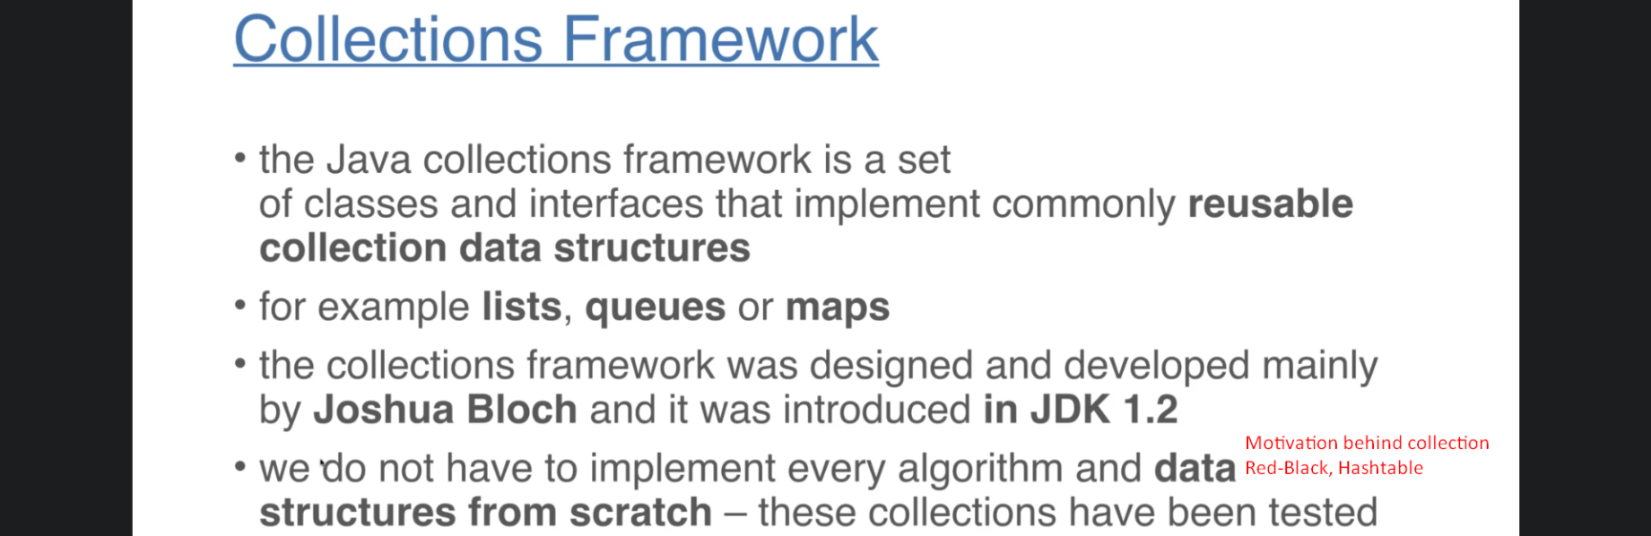
3. 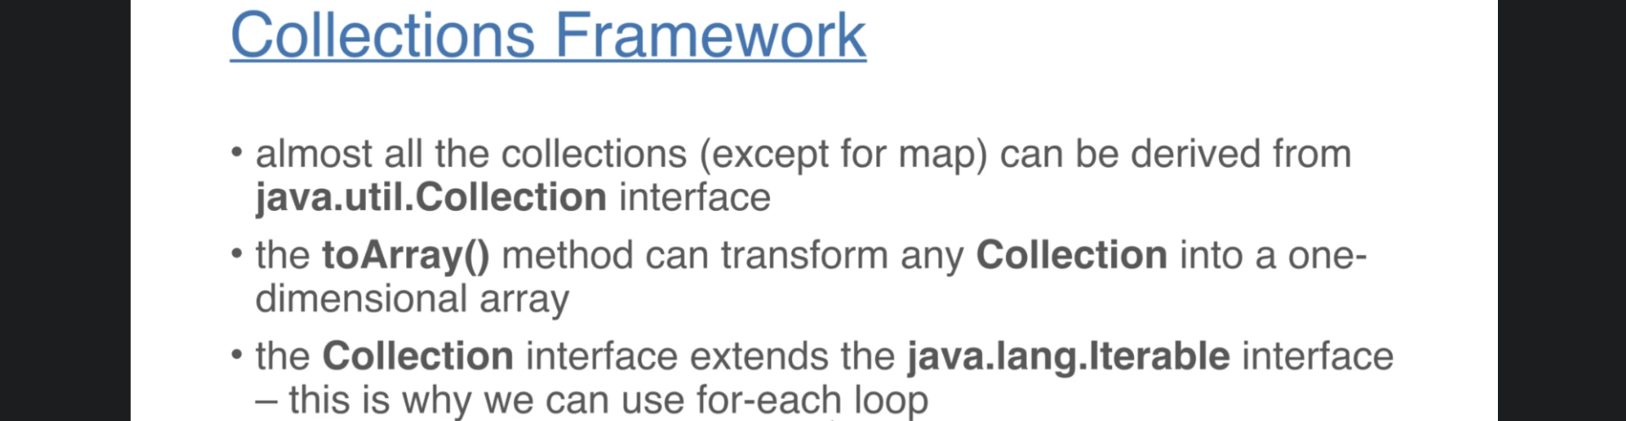
4. 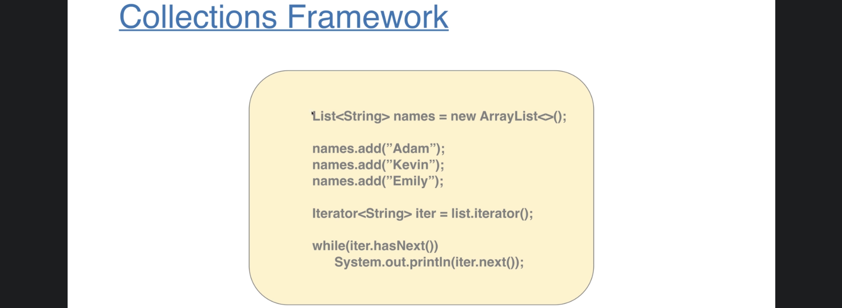
5. 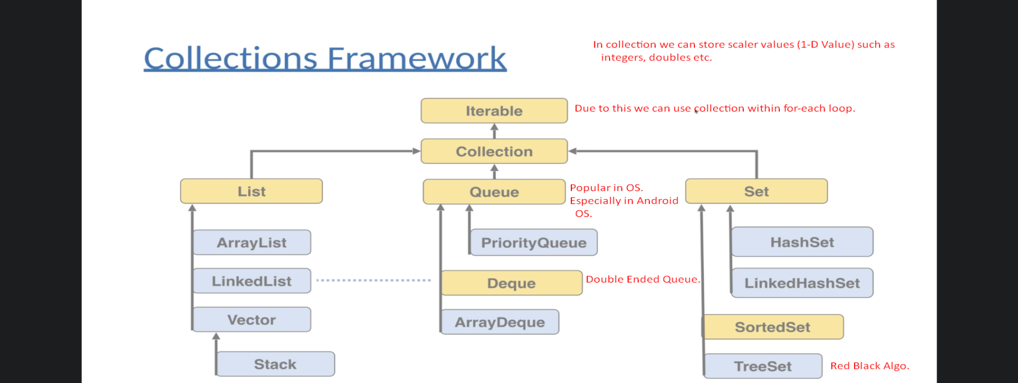
6. Map:
   1. Map interface doesn’t extend the collection interface.
   2. We can’t store scalar values. We are not going to store simple values but going to store values associated with a given keys and we are going to identify single value based on those keys.
7. 